Data Handling and Visualization (DSA06)
Name: Prasanna M Reg. No: 1925260244
Set 20: Stock Analysis
Question 1. Create a line chart to visualize the stock prices of three companies (Stock A, Stock B, and Stock C) over a specific time period. Label the axes and title the chart.
Program (R):
library(ggplot2); library(tidyr)
stock <- data.frame(Date = as.Date(c("2023-01-01","2023-01-02","2023-01-03")),
StockA = c(100,105,110), StockB = c(150,152,148), StockC = c(120,118,122))
long <- pivot_longer(stock, cols = starts_with("Stock"), names_to = "Stock", values_to = "Price")
ggplot(long, aes(x = Date, y = Price, colour = Stock)) +
geom_line(linewidth = 1) + geom_point(size = 2) +
labs(title = "Stock Prices of Three Companies", x = "Date", y = "Price ($)") +
theme_minimal()
Output:
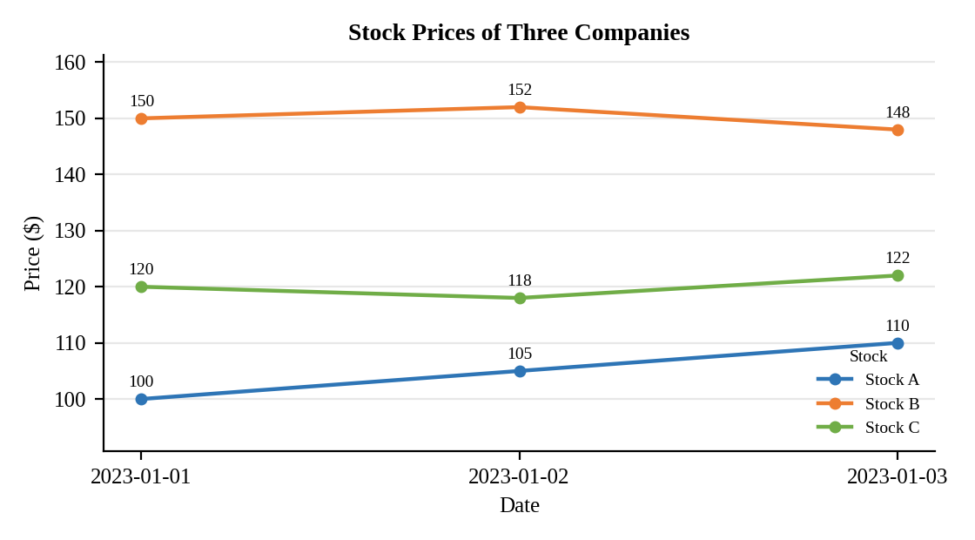
Interpretation:
Stock A rises every day (100 to 110, +10%). Stock B has the highest price but moves up and then down (150, 152, 148). Stock C dips on 2 January and recovers to 122 on 3 January.

Question 2. Generate a bar chart showing the daily percentage change in stock prices for Stock A. Label the chart elements.
Program (R):
stock$PctChange <- c(NA, diff(stock$StockA) / head(stock$StockA, -1) * 100)
ggplot(na.omit(stock), aes(x = Date, y = PctChange)) +
geom_col(fill = "steelblue", colour = "black", width = 0.5) +
geom_text(aes(label = paste0(round(PctChange, 2), "%")), vjust = -0.3) +
labs(title = "Daily Percentage Change in Stock A", x = "Date", y = "Change (%)") +
theme_minimal()
Output:
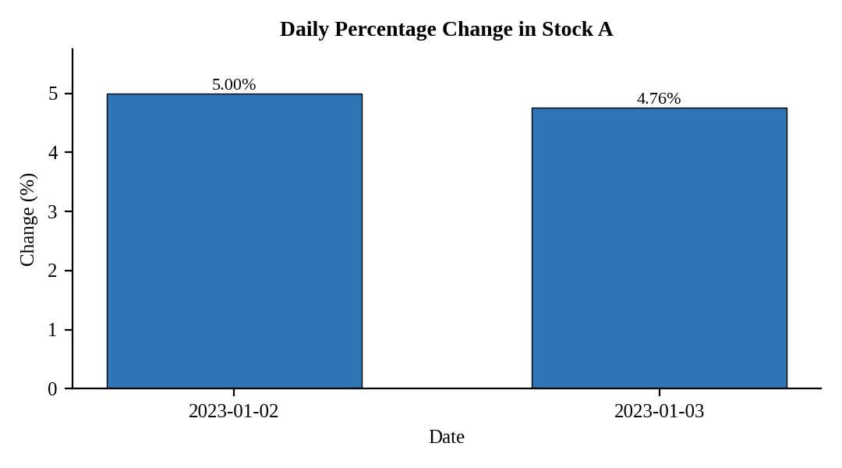
Interpretation:
Stock A gained 5.00% on 2 January and 4.76% on 3 January. The gains are steady, with a slightly smaller increase on the second day. No percentage change exists for 1 January because it is the first observation.

Question 3. Build a table to display the stock price data for each company over the given period. Label the table elements.
Program (R):
library(knitr)
kable(stock[, c("Date","StockA","StockB","StockC")], align = "c",
col.names = c("Date","Stock A ($)","Stock B ($)","Stock C ($)"),
caption = "Table 20.1: Stock Price Data")
Output:
Table 20.1: Stock Price Data
Date | Stock A ($) | Stock B ($) | Stock C ($)
2023-01-01 | 100 | 150 | 120
2023-01-02 | 105 | 152 | 118
2023-01-03 | 110 | 148 | 122

Interpretation:
Over the three days Stock A gained 10 dollars, Stock C gained 2 dollars and Stock B lost 2 dollars from its 2 January peak. Average prices are 105 (A), 150 (B) and 120 (C).

Question 4. Develop a Tableau dashboard combining the line chart, bar chart, and the table for interactive exploration of stock prices.
Procedure (Tableau):
1. Open Tableau, click Connect, choose Text file / Microsoft Excel, select "Stock_Prices.csv" and open Sheet 1.
2. Select Stock A, Stock B and Stock C, right-click and choose Pivot. Rename the fields to "Stock" and "Price".
3. Sheet 1 (Line): Columns = Date (Day, continuous); Rows = SUM(Price); Color = Stock.
4. Sheet 2 (Bar): create a Table Calculation on SUM(Price): Percent Difference from Previous, computed along Date; Columns = Date; Rows = this calculation; filter Stock = Stock A; add labels.
5. Sheet 3 (Table): Rows = Date; Columns = Stock; Text = SUM(Price).
6. Click New Dashboard, name it "Stock Dashboard", set Size to Automatic and drag the sheets onto the canvas (charts on top, table below).
7. Select each chart and click the "Use as Filter" icon so that clicking a bar or slice filters the other sheets; keep tooltips enabled.
8. Add a title to every sheet, adjust labels and colours, and save the workbook (File > Save As, .twbx).

Output:
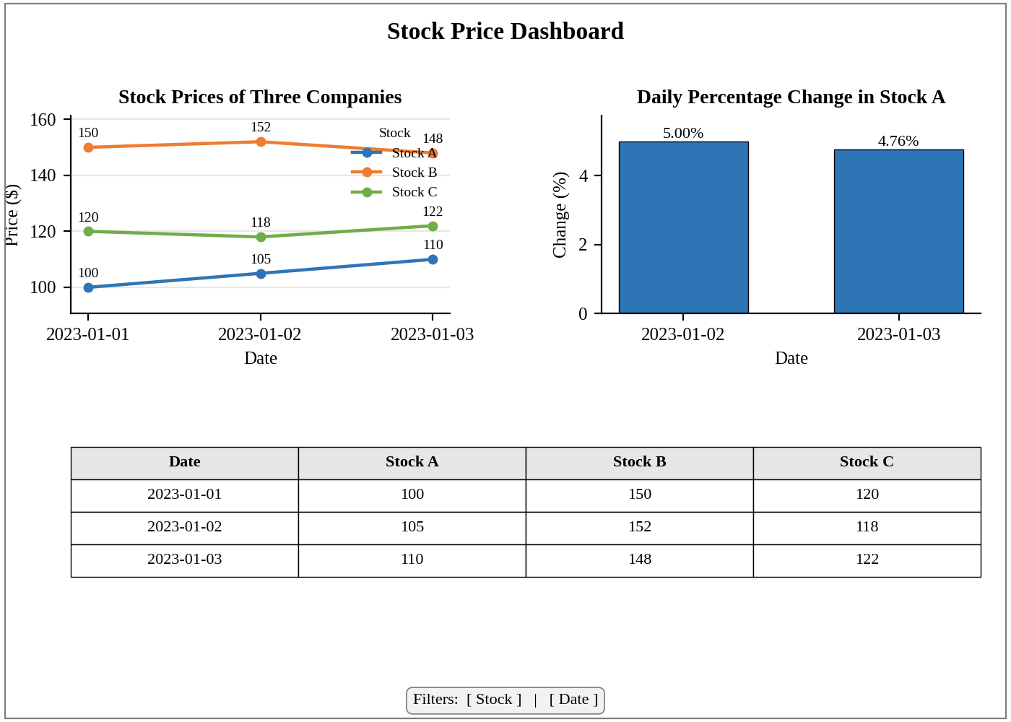
Dashboard layout (preview of the Tableau output).
Interpretation:
The Stock and Date filters change the line chart, the percentage-change bars and the table together. The dashboard lets an investor compare the three stocks and see Stock A as the steadiest gainer.

